

COP4600
Ex0: Bionic Beaver Setup

Overview
You will setup and build Ubuntu 18.04.3 Bionic Beaver. You will then take a screenshot showing the Ubuntu terminal and submit it through Canvas.

Nota bene: many of these operations will take some time – downloading large amounts of data, changing settings, rebuilding a large system. Start early and leave yourself plenty of time to deal with surprises! Some troubleshooting help is available at the end of this document.

Structure
This exercise is broken into three main parts:

- Installing VirtualBox v6.1 / WSL
- Importing our customized Ubuntu base including source code
- Building a Fresh Kernel

Software Setup
First, we need to get the virtual machine and terminal software set up.

Download
VirtualBox v6.1+ & Extension Pack
This may require you to do two downloads – one for VB and another for the EP.
Ubuntu OS Image: 18.04.3 LTS
This will require you to have a decompression application such as 7zip to unzip the files. Put the files in a convenient place you can find them when loading the image into VB. You may have to copy the URL and paste it if Google Drive complains about your browser. This is not the standard Ubuntu 18.04.3 image, but has been pared down so that system builds are faster and smaller.

VirutalBox Installation
- Install VirtualBox
- Navigate to File → Preferences → Extensions to install the extension pack.
Note: Your extension pack must be compatible with the version of VB you installed. If not, then either uninstall VB and install the newer version, or download and install the older extension pack.
- Navigate to File → Import Appliance and select 18.04.3D[Final].ova
If VB complains or tells you you are not running 64-bit version, then you probably do not have virtualization enabled. See Troubleshooting below.
You may also double click or right click the.ova file and open it using VirtualBox.
- Navigate to settings → system and select maximum number of CPU cores, so your system builds are as fast as possible (see below).

- If you are running Windows, install WSL: https://docs.microsoft.com/en-us/windows/wsl/install-win10

You will use WSL to “remotely” access Ubuntu using a Linux window on your Windows host. You can login and work from the shell in VB, but often the host you are modifying may not have a “head” and you will have to login remotely. We want you to have that skill and experience.

Building a Fresh Kernel
To connect, start the Ubuntu virtual machine and connect to it through SSH via WSL:

finn@BMO:~$ ssh reptilian@localhost -p 9474 Password is 'reptilian'

Once connected, change to the /usr/rep/src directory, then clone the kernel repository:

reptilian@ubuntu-vb$ cd /usr/rep/src
reptilian@ubuntu-vb$ apt source linux-image-unsigned-5.0.0-37-generic
reptilian@ubuntu-vb$ cd linux-hwe-5.0.0
reptilian@ubuntu-vb$ git init && git add * && git commit -am “First Commit”
reptilian@ubuntu-vb$ cp -vi /boot/config-$(uname -r) .config
reptilian@ubuntu-vb$ ls
<screenshot #1 here>

Finally, build the kernel from source and install it into the operating system:
reptilian@ubuntu-vb$ make
<screenshot #2 here>
Nota bene: Do NOT use sudo for this first make command, as it will set restrictive file protections that will make your life miserable later.
reptilian@ubuntu-vb$ sudo make install
reptilian@ubuntu-vb$ sudo make modules_install
<screenshot #3 here>
This is a good time to take a first snapshot. At the very least you will need a clean snapshot on which to test your patch files, as this is the environment in which we will test your submissions.

Submissions
You will submit the following at the end of this exercise (do not zip files):

- Screenshot of a terminal window, connected via SSH, showing the kernel source directory (using ls)
- Screenshot after running the sudo make command
- Screenshot after running the sudo make modules_install command

Example Screenshots
Here are some examples of what your screenshots should look like (except for the directory location):

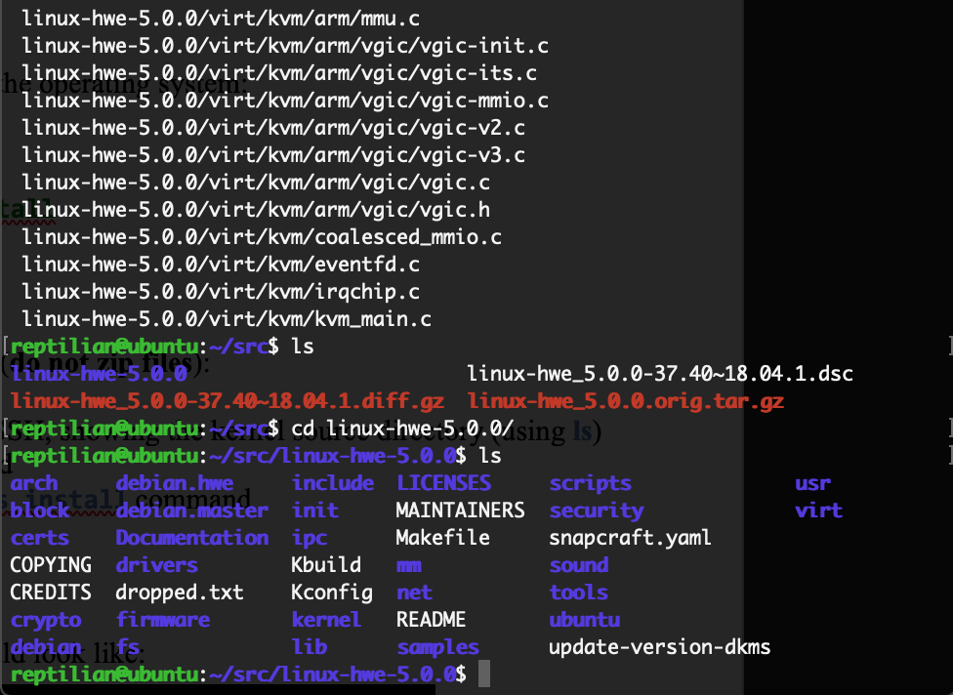
Figure 1. Screenshot #1 showing the source in /usr/rep/src/linux-hwe-5.0.0

Figure 2. Screenshot #3 showing terminal after running sudo make modules_install

Troubleshooting

Software Setup
If you already have an earlier version of VB installed, you may need to uninstall it first. If your OS is Windows then you can just install the new version on top of the old version (assuming it is 2.x or above).

If your OS is Linux and you are updating to a new major release (i.e., your current version is 5.1 or below), then you will need to fully uninstall the old version and purge residual config.
Additionally, if you are running Linux and the extension pack installation fails with “Error creating textual authentication agent,” you will need to install the extension pack with administrator privileges from the command-line. The following command should successfully install the extension pack:
sudo vboxmanage extpack install --replace path/to/downloaded/extpack.vbox-extpack
In all cases, if you have an existing OSE package and are replacing with a PUEL version to get USB support, then you will need to properly remove the OSE package first.
Help is available at https://forums.virtualbox.org/

Running Ubuntu
To run, you may need to enable virtualization in BIOS. You will get an error message in VirtualBox when it tries to boot saying that VT-x/AMD-V is not available.

You can check if virtualization is enabled or not (and if it is available) on Windows 10 from the task manager under Performance and CPU. At the bottom of this screen showing dynamic CPU utilization is a plethora of information. About halfway down the list on the right should be “virtualization.” If it says enabled, you are fine. If it says disabled, then you need to enable it in the BIOS. If it says not available, then you are out of luck.

To get to BIOS on Windows 10 and enable hardware support for virtualization (VT-x/AMD-V)
- Go to start menu
- Select Settings (gear icon on the left)
- Select Update and Security (at the bottom)
- Select Recovery (in pane on the left)
- Click restart now button in Advanced Startup Section
- When the new screen appears, select Troubleshoot
- Select Advanced Options
- Select UEFI Firmware Settings
- Restart
- System will restart in the boot manager
- Select “Enter Setup” under Diagnostics
- Select “Advanced” tab at top of setup utility
- Change virtualization setting to enabled
- Save and exit

Additional Hints
Want to speed up compilation? Assign more threads to the VM and when running make, use the -j option to enable multithreaded compilation. For more information and how to use multithreaded compilation, run man make.

FAQ

Q: Can I delete all the unused kernels then?

A: No, you should keep at least one original kernel so that you may revert to a guaranteed working kernel
without having to go through the trouble of restoring a snapshot.

If your 5.0.21 kernel panics, restart the VM and within the GRUB menu, select Advanced Options for
Ubuntu and boot from the old kernel 5.0.21.old

If you boot from the 5.0.21 kernel from the GRUB because the latest 5.0.21 panicked, you should remove the
5.0.21 kernel by doing the following:

reptilian@ubuntu-vb$ sudo rm -r /boot/*5.0.21
reptilian@ubuntu-vb$ sudo rm -r /lib/modules/5.0.21
reptilian@ubuntu-vb$ sudo rm -r /var/lib/initramfs-tools/5.0.21

Q: Can I use PuTTY/Cygwin/etc. instead of WSL to do access my VM?

A: While you can use whatever method you prefer to access the VM, only WSL will be officially supported by the TA’s. Only use an alternative if you are feeling adventurous.

Q: Can I directly login to the VM from the VirtualBox window?

A: While it is possible to login directly, for this assignment, a remote access tool must be used. It is also necessary to login to the virtual machine through SSH, as SFTP is needed to move files between the host OS and the guest OS; testing the ability to do so now will save heartache down the road.

Q: Can I just do these screenshots on a native install of Ubuntu instead of using the VM?

A: While it is entirely possible to do this, it is strongly discouraged. This exercise is for you to set up the virtual machine that you will be using for the rest of this course. Many of the assignments you will do in this class could break the OS if they are done incorrectly. Therefore, you will need to take snapshots of your virtual Ubuntu OS throughout the semester. Doing that on a native installation could lead to data corruption and lost time due to the effort required to restore a broken native installation. On the other hand, with a virtual machine, rollback to the previous state can be done with a click of a button.

Screenshots

Use ALT-Fn-PrtSc to capture the active window. The shot may be under Pictures or under Videos\Captures. You may also use the snipping tool to select the screenshot you wish.

